**Door Monitor Project- Second Deliverable**

**March 29, 2023**

Darri, Zoralla, Caidence

<https://github.com/darristuber/CSC-102-FINAL-PROJECT.git>

**Goals and Objectives**

* ~~Create a system to monitor the opening/closing of a door~~
* Capture a photo ~~when the door is opened during “off” periods of time~~  when motion is detected in front of the sensor
* Store the photo on a local storage device
* Make a sound when a photo is captured

**GPIO Goals**

* ~~Detect door state (open/closed) using a motion sensor (~~[~~$1.95~~](https://www.adafruit.com/product/5578)~~)~~
* Capture an image upon sensing motion during “off periods” using a camera ([$30](https://www.adafruit.com/product/3099)/[$12.50](https://www.adafruit.com/product/3202))
  + We will now be keeping the camera on and it will only capture a photo when motion is detected
* Utilize other GPIO components (i.e. Breadboard, Pushbuttons, Jumper Wires)
  + The hardware does not require the use of the breadboard or pushbuttons. The hardware is able to connect to the Raspberry Pi directly.

**Timeline**

|  |  |  |  |  |  |  |  |  |  |  |  |  |  |  |  |
| --- | --- | --- | --- | --- | --- | --- | --- | --- | --- | --- | --- | --- | --- | --- | --- |
|  | Wk. 1 | Wk. 2 | Wk. 3 | Wk. 4 | Wk. 5 | Wk. 6 | Wk. 7 | Wk. 8 | Wk. 9 | Wk. 10 | Wk. 11 | Wk. 12 | Wk. 13 | Wk. 14 | Wk. 15 |
|  | Week of | | | | | | | | | | | | | | |
|  | 1/23 | 1/30 | 2/6 | 2/13 | 2/20 | 2/27 | 3/6 | 3/13 | 3/20 | 3/27 | 4/3 | 4/10 | 4/17 | 4/24 | 5/1 |
| First Deliverable |  |  |  |  |  |  |  |  |  |  |  |  |  |  |  |
| Design Project Idea |  |  |  |  |  |  |  |  |  |  |  |  |  |  |  |
| Initial Write-up |  |  |  |  |  |  |  |  |  |  |  |  |  |  |  |
| Plan Presentation |  |  |  |  |  |  |  |  |  |  |  |  |  |  |  |
| Second Deliverable |  |  |  |  |  |  |  |  |  |  |  |  |  |  |  |
| Ordering Items |  |  |  |  |  |  |  |  |  |  |  |  |  |  |  |
| Coding |  |  |  |  |  |  |  |  |  |  |  |  |  |  |  |
| Preliminary Prototype |  |  |  |  |  |  |  |  |  |  |  |  |  |  |  |
| Updated Write-Up |  |  |  |  |  |  |  |  |  |  |  |  |  |  |  |
| Plan Presentation |  |  |  |  |  |  |  |  |  |  |  |  |  |  |  |
| Third Deliverable |  |  |  |  |  |  |  |  |  |  |  |  |  |  |  |
| Improve Code |  |  |  |  |  |  |  |  |  |  |  |  |  |  |  |
| Working Prototype |  |  |  |  |  |  |  |  |  |  |  |  |  |  |  |
| Updated Write-Up |  |  |  |  |  |  |  |  |  |  |  |  |  |  |  |
| Fourth Deliverable |  |  |  |  |  |  |  |  |  |  |  |  |  |  |  |
| Finish Coding |  |  |  |  |  |  |  |  |  |  |  |  |  |  |  |
|  |  |  |  |  |  |  |  |  |  |  |  |  |  |  |  |
| Completed Project |  |  |  |  |  |  |  |  |  |  |  |  |  |  |  |
| Final Presentation |  |  |  |  |  |  |  |  |  |  |  |  |  |  |  |
| Final Write-Up |  |  |  |  |  |  |  |  |  |  |  |  |  |  |  |

**Improvements:**

* Added the camera to the side of the door rather than the side. Maybe find a way to extend the connection between the breadboard and the camera so the breadboard is out of sight.
* Add night vision capabilities, or be able to detect motion in dim lighting. Found a high-powered LED that can help detect in the dark (<https://www.adafruit.com/product/387#description>) <https://www.pcguide.com/raspberry-pi/how-to/make-private-ring-doorbell/>

**Layout**:

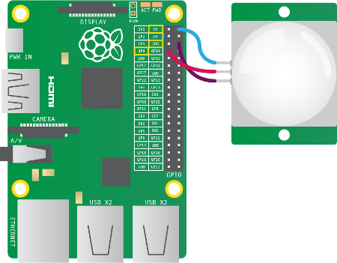 PIR motion sensor

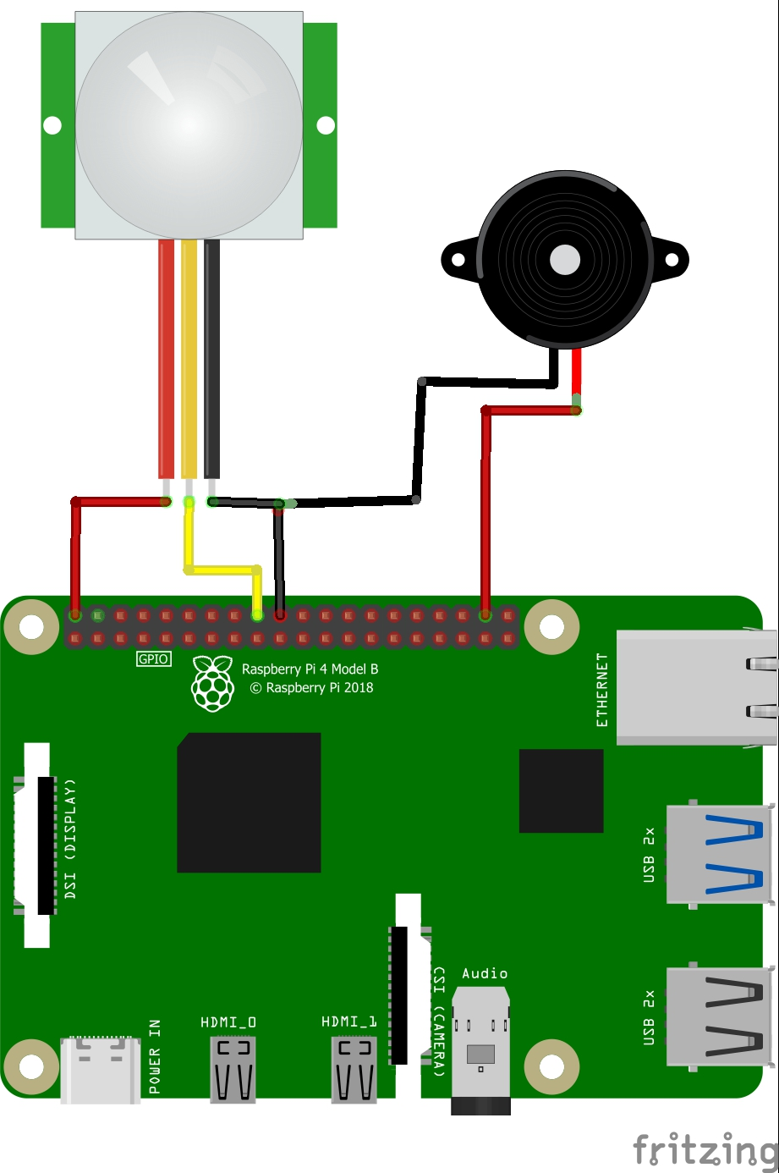

Raspberry pi setup with pi camera and motion sensor

Actual setup:

